BANK LOAN REPORT QUERY DOCUMENT
- BANK LOAN REPORT | SUMMARY

KPI’s:
Total Loan Applications
select COUNT(id) AS Total_Loan_Applications from dbo.financial_loan$

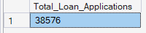
MTD Loan Applications
select COUNT(id) AS MTD_Total_Loan_Applications from dbo.financial_loan$
WHERE MONTH(issue_date) = 12 AND YEAR(issue_date) = 2021

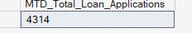
PMTD LOAN Applications
select COUNT(id) AS PMTD_Total_Loan_Applications from dbo.financial_loan$
WHERE MONTH(issue_date) = 11AND YEAR(issue_date) = 2021

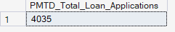

Total Funded Amount
SELECT SUM(loan_amount) AS Total_Funded_Amount FROM dbo.financial_loan$

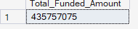
MTD Total Funded Amount
select SUM(loan_amount) AS MTD_Total_Funded_Amount FROM dbo.financial_loan$
where MONTH(issue_date) =12 AND YEAR(issue_date) = 2021

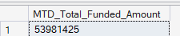
PMTD Total Funded Amount
select SUM(loan_amount) AS PMTD_Total_Funded_Amount FROM dbo.financial_loan$
where MONTH(issue_date) =11 AND YEAR(issue_date) = 2021
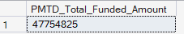

Total Received Amount
select SUM(total_payment) AS Total_Amount_Received FROM dbo.financial_loan$

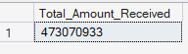
MTD Total Reveived Amount
select SUM(total_payment) AS MTD_Total_Amount_Received FROM dbo.financial_loan$
where MONTH(issue_date) = 12 AND YEAR(issue_date) = 2021

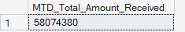
PMTD Total Received Amount
select SUM(total_payment) AS PMTD_Total_Amount_Received FROM dbo.financial_loan$
where MONTH(issue_date) = 11 AND YEAR(issue_date) = 2021

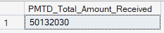

Average Interest Rate
select ROUND(AVG(int_rate),4) * 100 AS Avg_Interest_Rate FROM dbo.financial_loan$

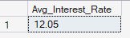
MTD Average Interest Rate
select ROUND(AVG(int_rate),4) * 100 AS MTD_Avg_Interest_Rate FROM dbo.financial_loan$
where MONTH(issue_date) = 12 AND YEAR(issue_date) = 2021

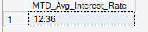
PMTD Average Interest Rate
select ROUND(AVG(int_rate),4) * 100 AS PMTD_Avg_Interest_Rate FROM dbo.financial_loan$
where MONTH(issue_date) = 11 AND YEAR(issue_date) = 2021

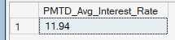

Average Debt-to-Income Ratio (DTI)
select ROUND(AVG(dti),4) * 100 AS Avg_DTI FROM dbo.financial_loan$

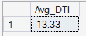
MTD Average Debt-to-Income Ratio (DTI)
select ROUND(AVG(dti),4) * 100 AS MTD_Avg_DTI FROM dbo.financial_loan$
where MONTH(issue_date) = 12 AND YEAR(issue_date) = 2021

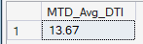
PMTD Average Debt-to-Income Ratio (DTI)
select ROUND(AVG(dti),4) * 100 AS PMTD_Avg_DTI FROM dbo.financial_loan$
where MONTH(issue_date) = 11 AND YEAR(issue_date) = 2021

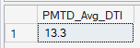

Good Loan v Bad Loan KPI’s
Good Loan Issued
Good Loan Application Percentage
select
(COUNT(CASE WHEN loan_status = 'Fully Paid' OR loan_status = 'Current' THEN id END) * 100)
/
COUNT(id) AS Good_loan_percentage
FROM dbo.financial_loan$

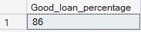
Good Loan Applications
select COUNT(id) AS Good_Loan_Applications FROM dbo.financial_loan$
WHERE loan_status = 'Fully Paid' OR loan_status = 'Current'

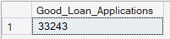
Good Loan Funded Amount
select SUM(loan_amount) AS Good_Loan_Funded_Amount FROM dbo.financial_loan$
WHERE loan_status = 'Fully Paid' OR loan_status = 'Current'

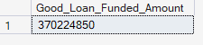
Good Loan Amount Received
select SUM(total_payment) AS Good_Loan_Received_Amount FROM dbo.financial_loan$
WHERE loan_status = 'Fully Paid' OR loan_status = 'Current'

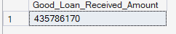

Bad Loan Issued
Bad Loan Percentage
select
(COUNT(CASE WHEN loan_status = 'Charged Off' THEN id END) * 100) /
COUNT(id) AS Bad_Loan_Percentage
FROM dbo.financial_loan$

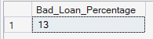
Bad Loan Applications
select COUNT(id) AS Bad_Loan_Applications FROM dbo.financial_loan$
WHERE loan_status = 'Charged Off'

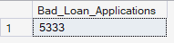
Bad Loan Funded Amount
select SUM(loan_amount) AS Bad_Loan_Funded_Amount FROM dbo.financial_loan$
WHERE loan_status = 'Charged Off'

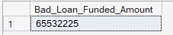
Bad Loan Amount Received
select SUM(total_payment) AS Bad_Loan_Amount_Received FROM dbo.financial_loan$
WHERE loan_status = 'Charged Off'

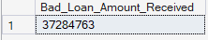

LOAN STATUS

select
loan_status,
COUNT(id) AS Total_Loan_applications,
SUM(total_payment) AS Total_Amount_Received,
SUM(loan_amount) AS Total_Funded_Amount,
AVG(int_rate * 100) AS Interest_Rate,
AVG(dti * 100) AS DTI
FROM
dbo.financial_loan$
GROUP BY
loan_status

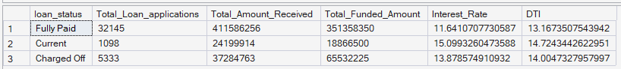

select
loan_status,
SUM(total_payment) AS MTD_Total_Amount_Received,
SUM(loan_amount) AS MTD_Total_Funded_Amount
FROM dbo.financial_loan$
WHERE MONTH(issue_date) = 12
GROUP BY loan_status

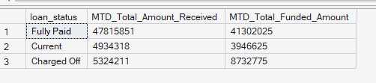
MONTH
select
MONTH(issue_date) AS Month_Number,
DATENAME(MONTH,issue_date) AS Month_Name,
COUNT(id) AS Total_Loan_Applications,
SUM(loan_amount) AS Total_Funded_Amount,
SUM(total_payment) AS Total_Received_Amount
FROM dbo.financial_loan$
GROUP BY MONTH(issue_date), DATENAME(MONTH, issue_date)
ORDER BY MONTH(issue_date)

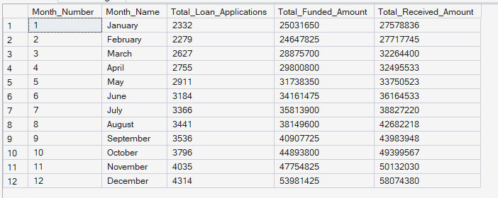
Regional Analysis by State
select
address_state,
COUNT(id) AS Total_Loan_Applications,
SUM(loan_amount) AS Total_Funded_Amount,
SUM(total_payment) AS Total_Received_Amount
FROM dbo.financial_loan$
GROUP BY address_state
ORDER BY address_state

address_state | Total_Loan_Applications | Total_Funded_Amount | Total_Received_Amount
AK | 78 | 1031800 | 1108570
AL | 432 | 4949225 | 5492272
AR | 236 | 2529700 | 2777875
AZ | 833 | 9206000 | 10041986
CA | 6894 | 78484125 | 83901234
CO | 770 | 8976000 | 9845810
CT | 730 | 8435575 | 9357612
DC | 214 | 2652350 | 2921854
DE | 110 | 1138100 | 1269136
FL | 2773 | 30046125 | 31601905
GA | 1355 | 15480325 | 16728040
HI | 170 | 1850525 | 2080184
IA | 5 | 56450 | 64482
ID | 6 | 59750 | 65329
IL | 1486 | 17124225 | 18875941
IN | 9 | 86225 | 85521
KS | 260 | 2872325 | 3247394
KY | 320 | 3504100 | 3792530
LA | 426 | 4498900 | 5001160
MA | 1310 | 15051000 | 16676279
MD | 1027 | 11911400 | 12985170
ME | 3 | 9200 | 10808
MI | 685 | 7829900 | 8543660
MN | 592 | 6302600 | 6750746
MO | 660 | 7151175 | 7692732
MS | 19 | 139125 | 149342
MT | 79 | 829525 | 892047
NC | 759 | 8787575 | 9534813
NE | 5 | 31700 | 24542
NH | 161 | 1917900 | 2101386
NJ | 1822 | 21657475 | 23425159
NM | 183 | 1916775 | 2084485
NV | 482 | 5307375 | 5451443
NY | 3701 | 42077050 | 46108181
OH | 1188 | 12991375 | 14330148
OK | 293 | 3365725 | 3712649
OR | 436 | 4720150 | 4966903
PA | 1482 | 15826525 | 17462908
RI | 196 | 1883025 | 2001774
SC | 464 | 5080475 | 5462458
SD | 63 | 606150 | 656514
TN | 17 | 162175 | 141522
TX | 2664 | 31236650 | 34392715
UT | 252 | 2849225 | 2952412
VA | 1375 | 15982650 | 17711443
VT | 54 | 504100 | 534973
WA | 805 | 8855525 | 9531739
WI | 446 | 5070450 | 5485161
WV | 167 | 1830525 | 1991936
WY | 79 | 890750 | 1046050

Loan Term
select
term,
COUNT(id) AS Total_Loan_Applications,
SUM(loan_amount) AS Total_Funded_Amount,
SUM(total_payment) AS Total_Received_Amount
FROM dbo.financial_loan$
GROUP BY term
ORDER BY term
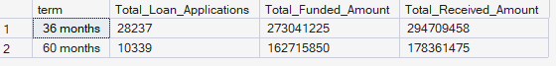
Employee Length
select
emp_length,
COUNT(id) AS Total_Loan_Applications,
SUM(loan_amount) AS Total_Funded_Amount,
SUM(total_payment) AS Total_Received_Amount
FROM dbo.financial_loan$
GROUP BY emp_length
ORDER BY emp_length

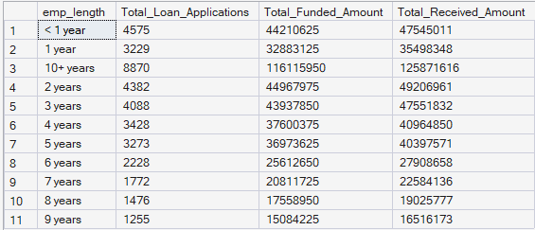
Loan Purpose Breakdown
select
purpose,
COUNT(id) AS Total_Loan_Applications,
SUM(loan_amount) AS Total_Funded_Amount,
SUM(total_payment) AS Total_Received_Amount
FROM dbo.financial_loan$
GROUP BY purpose
ORDER BY purpose

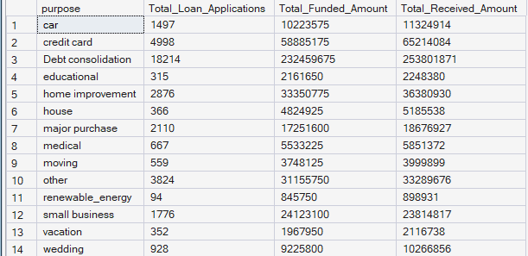

Home Ownership
select
home_ownership,
COUNT(id) AS Total_Loan_Applications,
SUM(loan_amount) AS Total_Funded_Amount,
SUM(total_payment) AS Total_Received_Amount
FROM dbo.financial_loan$
GROUP BY home_ownership
ORDER BY COUNT(id) DESC

